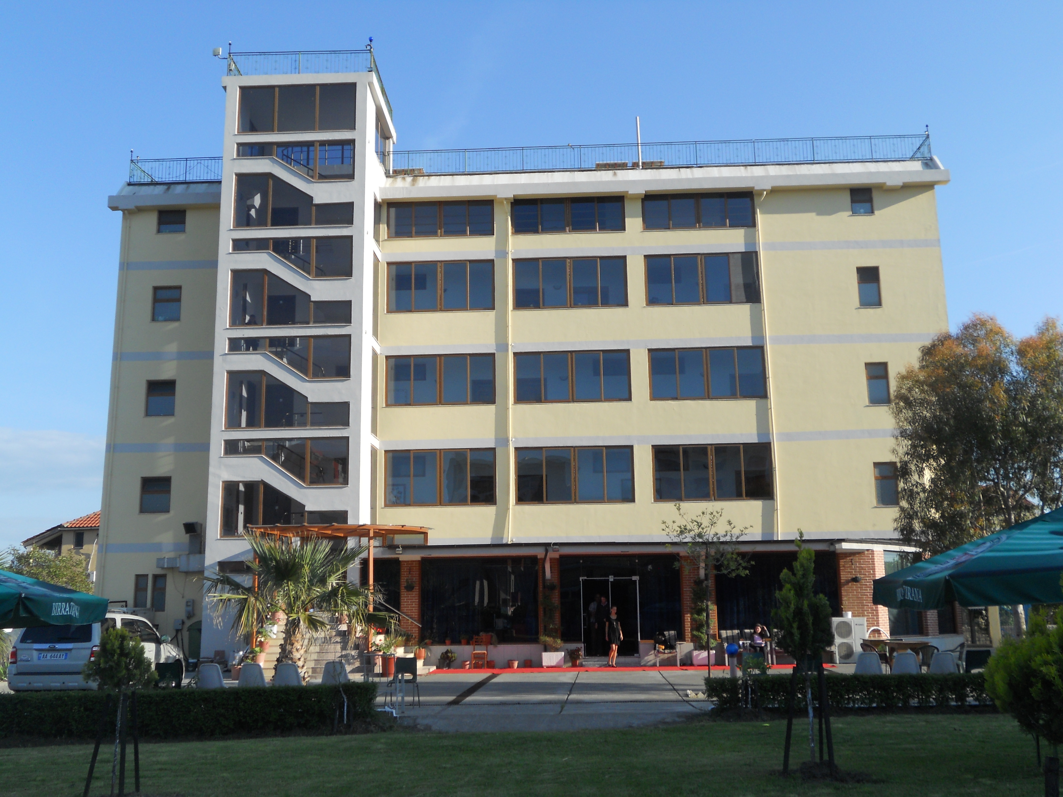

LEZHA ACADEMIC CENTER

Vëllezrit Çoku
Lezhë, Albania
Viti Shkollor 2024-2025
Phone:0692065940
E-mail:lezhaacademiccenter@gmail.com

Registration in LAC is considered complete when:

- ✓ Student and family application
- ✓ $100 non-refundable application fee
- ✓ Copies of the most recent reports for students of previous schools
- ✓ Official receipt from the sending school
- ✓ Other additional documents that may be required by LAC

APPLICATION FOR STUDENTS AND FAMILIES

Application for the class of (circle one) 1 2 3 4 5 6 7 8 9 10 11 12
Date of application ____________________________________

Student Information (Please write clearly)

Name Paternity Surname _________________________________________________ Gender___________

Adress __________________________________________________________Phone number____________________

Birthday ______________________________Nationality__________________________________________

ID card no. ___________________________ The last school you attended

_______________________________________________Adress__________________________________________

Describe in your own words why you want to be part of Lezha Academic Center:

___________________________________________________________________________________________________________________________________________________________________________________________________________________________________________________________________________________________________

Family Background

Father

First and Last Name _______________________________________________________________________________

E-mail ___________________________________________ Phone number _________________________

Occupation__________________________________ The employer

__________________________________

Phone number __________________________

Mother

First and Last Name _____________________________________________________________________________

Phone number __________________________________________

Occupation__________________________________ The Employer_________________________________

Phone number _________________________

Status of the student's parents: Married / Separated / Other _____________________

How did you hear about LAC?
__________________________________________________________________________________________________________________________________________________________________________________________________

Why do you want your child to enroll in LAC school?
__________________________________________________________________________________________________________________________________________________________________________________________________

Please indicate if you think your child has any special needs or abilities.
__________________________________________________________________________________________________________________________________________________________________________________________________

Educational services

Has the student ever had difficulties in school? YES NO
If YES, please describe_____________________________________________________________ __________________________________________________________________________________________________________________________________________________________________________________________________

Medical care

We authorize LAC to treat the student in case of need: YES NO
We authorize the LAC to call the doctor if necessary: ​​YES NO
We authorize LAC to call the ambulance in case of need: YES NO

Authorization to use photographs

Through this signature we allow LAC to use our child's photographs in various school publications.

___________________________________________________ _________________________________________

Authorization for data transfer

By our signature we authorize the academic and health records of __________________________________ to be transferred from the school of __________________________
at the LAC school.

SIGNATURE OF APPLICANTS

____________________________________ _______________________________________
FATHER MOTHER

DATE__________________________________

Note: The submission of this document is accompanied by the payment of the registration fee.

